Lab: Edit and Run Your 1st Python Program
(Turtle Graphics)

1. Lab Overview. 2
2. Install python. 2
3. Find a background image. 2
4. Write a python program that shows the background image. 3
5. Select a color to use for drawing a border around your image. 3
6. How to Position the Turtle and Draw a Line 3
7. Draw a border around your image. 5
8. Draw at least two shapes. 5
9. If you want to draw semi-circles. 7
10. Write your name on the bottom right corner of your image. 8
11. Ask the user to give you a title for your picture and tell you what color they want for the text. 8
12. Add Comments 8
13. Are you done yet? (Grading / Requirements Check list) 9
14. Get a Screen Capture. 9
15. Homework Submission. 10

Lab Overview.
In this lab, you will find a background image (gif) then write a python program that
- Asks the user what text and color they want for the title.
- Displays the image and writes the title (that the user wants).
- Draws a border around its edge.
- Draws some shapes on it.
- Writes your name at the bottom of the picture.
Here is a screen capture of the output of a program that meets these requirements. The title, artist name and two “boats” were all drawn with Turtle Graphics.
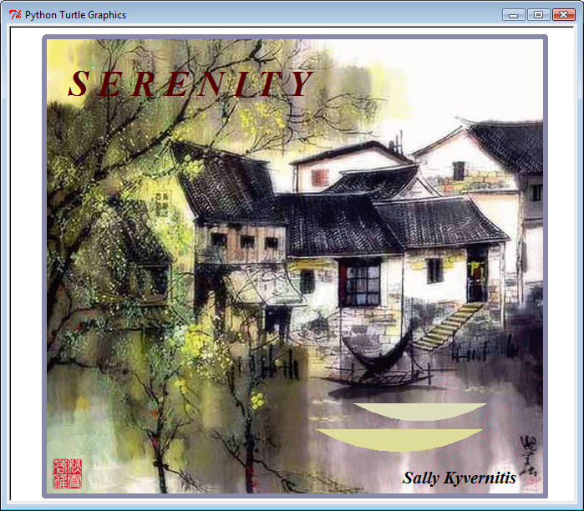

Install python.
Install python on your computer at home following the instructions in a separate document which is attached to this lab in Blackboard. Even if you will not be installing python at home (and you will be using python that is already installed in the Wachman labs), you still need to read the end of those instructions, where it tells you how to create and run a python program (“helloWorld.py”).

Find a background image.
- Go to google, click on images, search for “gif scenery”. Since we do not want super large files, click on “search tools” and select Size “medium”. You can also click on “More Tools” and “Show Sizes”. Try to select an image that is not larger than around 800 x 800 pixels
- Find a picture that you would like to use as a background for your lab. Note: animated gifs will not be animated when displayed by Turtle Graphics, so don’t spend too much time looking for cool animated gifs.
- Once you find an image you want to use for background scenery, click on that image to see the full sized version of the image. Then right click on that and do a “Image Save As”. If the file name does not have a “gif” at the end of it, select another image (only gifs work in Turtle Graphics). As you save the image, change the file name to be something short and representative of the image (no spaces or special characters in the file name) and keep the “.gif” file name extension.

Write a python program that shows the background image. (Important Note: Do not name it turtle.py)
Here is some sample code for this.
import turtle # bring in code that lets you draw things
turtle.bgpic("yourImageName.gif") # specify the name of your background image
turtle.resizemode("user") # if you want to let the user to resize the screen
turtle.done() # you need this to stop the window from closing immediately after drawing

Run it to be sure it works.
- If you forget how to edit and run a python program, refer to the installation document.
- If you get “python is not recognized”, the installation document tells you how to add python to your computer’s path.
- If your program runs, but cannot find the image, make sure that your python program is in the same folder as your background image file (which must be a gif and must have “gif” as it’s filename extension).
- If your program shows a traceback error involving “import turtle” module, re-name the file and try again.

Select a color to use for drawing a border around your image.
While you could select a color name, like “red” or “blue”, you’ll get better color selection if you use a color number as shown below.
turtle.color("#0088FF") # This RGB color has no red (00), half blue (88), and max green (FF) . It’s turquoise.
When you use RGB to specify a color, the first two hexadecimal digits tell how much Red, the second two digits how much Green, and the last two digits how much Blue. In our normal decimal number system, digits go from 0..9. In hexadecimal, the digits go from 0, 1, …, 9, A, B, C, D, E, F. You can use this link to understand and/or help you select a hexadecimal RGB color number for your border.
http://www.w3schools.com/html/html_colors.asp

How to Position the Turtle and Draw a Line
Imagine that a turtle is walking around the screen with a pen attached – as the turtle moves, the pen can either be up (not writing) or down (writing). You can tell the turtle where to go by providing a left/right coordinate and an up/down coordinate: turtle.goto(x,y). The x value tells the left/right position. 0 is middle, negative is left, and positive is right. The y value tells the up/down position. 0 is middle, negative is bottom, and positive is top. Here are some examples for you:
- turtle.goto (0,0) # goes to the middle of the screen
- turtle.goto (-200, 200) # goes to the left top (assuming 400x400)
- turtle.goto (200, 200) # goes to the right top

You can change the speed of the graphics like this:
turtle.speed("fastest") # other options are “fast”, “normal”, “slow”, “slowest”

This may be very helpful as you are “debugging” your program (slower if you want to see something as it is drawing, faster if you want it to hurry along).
So, if your code looked like this:
import turtle # bring in code that lets you draw things

turtle.bgpic("houses.gif") # specify the name of your background image
turtle.resizemode("user") # if you want to let the user to resize the screen

turtle.pensize (10) # make a thick line
turtle.speed("slow") # so you can see it better
turtle.goto (0,0) # goes to the middle of the screen (which is where it starts anyway)
turtle.goto (-200, 200) # goes to the left top (assuming a 400x400 size screen)
turtle.goto (200, 200) # goes to the right bottom (assuming a 400x400 size screen)

turtle.done() # you need this to stop the window from closing immediately after drawing

Your output should look like this:
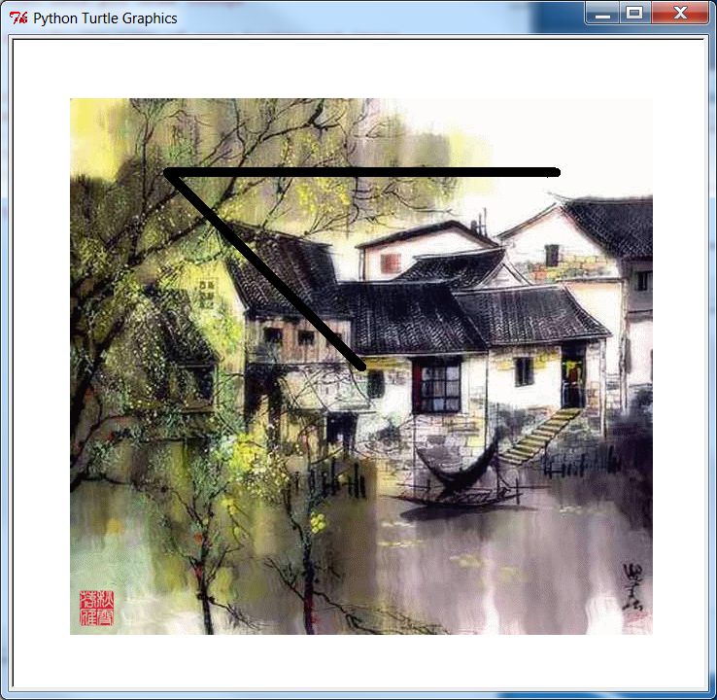

Draw a border around your image.
Draw a border around your image using the commands like those shown in the section above. Here is some sample code, but this code only draws part of the border. Your code will have to draw the whole border and 200 is probably not a large enough number to surround your image.
turtle.hideturtle() # if you want to hide the little arrow that marks where it’s drawing
turtle.color("#0088FF") # set the color of the pen
turtle.pensize(6) # bigger number means fatter lines, choose what you like
turtle.penup() # so no line is drawn from the beginning coordinate (0,0) to the next position
turtle.goto(200, 200) # 1st number is left/right (x coordinate), second is top/bottom (y coord)
turtle.pendown() # so it starts drawing as it moves to the next position
turtle.goto(200, -200) # first number is left/right (x coordinate), second is top/bottom (y)

Also, use variables as arguments to the turtle.goto( ) function. Do not use numbers as was just shown. This means that you need to create one variable hold the width of your image and another variable to hold the height of your image. As an example, I will show you how to use a variable for the pensize – make up a variable name, give it a value, then reference the variable name, like this:
myPenSize=4
turtle.pensize(myPenSize)

Always, use good variable names (not a and b or x and y, but something that helps you remember what the variable represents). Adjust the values of your variables until you get the border to exactly surround the edge of your picture.

Draw at least two shapes.
Draw at least two shapes on your background. Select shapes that fit in with your image. Here is some sample code. If you do not understand any of the sample code, the best way is to change something a little, and see how that affects it. If you ran this code, you’d see the window that’s shown on the next page.
import turtle

turtle.hideturtle() # if you want to hide the little arrow that marks where it’s drawing

turtle.pensize(3) # Set pen thickness to 3 pixels

# Draw purple circle with diameter 40 pixels
turtle.penup() # Pull the pen up (to avoid a line from the middle to your first point)
turtle.goto(200, -50)
turtle.pendown()# Put the pen down (so you begin drawing)
turtle.begin_fill() # Mark the beginning of the shape you want to later fill with color
turtle.color("purple")
turtle.circle(40) # Draw a circle (40 is the size of the circle)
turtle.end_fill() # Mark the end of the shape (for color fill) - the color is applied to the shape.

# Draw blue square with each side 60 pixels
turtle.penup()
turtle.goto(-100, -50)
turtle.pendown()
turtle.begin_fill() # Begin to fill color in a shape
turtle.color("blue")
turtle.circle(60, steps = 4) # Draw a square (sounds crazy, but like a 4 sided circle)
turtle.end_fill() # Fill the shape

# Draw red triangle that is about as large as a circle with diameter 80 pixels
turtle.penup() # Pull the pen up
turtle.goto(-200, -50)
turtle.pendown() # Put the pen down
turtle.begin_fill() # Begin to fill color in a shapeturtle.color("red")
turtle.circle(80, steps = 3) # Draw a triangle (it’s a triangle, because it used 3 sides or steps)
turtle.end_fill() # Fill the shape

The output would be like this:
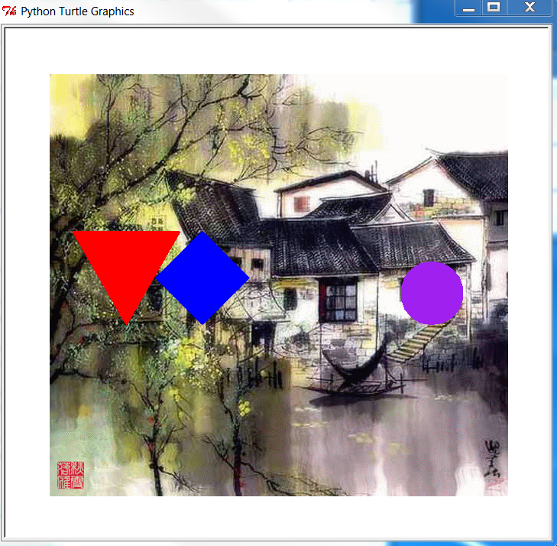
You can also reference this link to find other ideas for shapes you can draw:
http://docs.python.org/3.1/library/turtle.html#overview-of-available-turtle-and-screen-methods

If you want to draw semi-circles.
As indicated in the link above, you can also create filled semi-circles, such as was done to draw the boats in the screen capture at the beginning of this document.
To draw the semi-circles shown below,
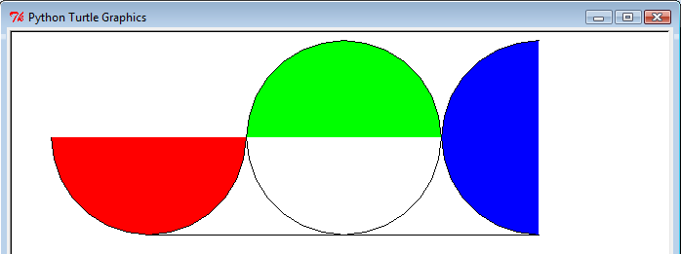
You could use the code below. I commented out the turtle.penup() to help show how it works. Apparently, when drawing circles, Turtle Graphics starts out at position 6 o’clock (bottom middle of a circle). If you end up at the top of one circle, you will be at the top again if you then begin to draw another circle. This is why I tried to always position myself at the bottom middle of each circle (after drawing any semi-circle), just to make things easier to follow. You can use penup() to suppress the black lines between the circles.
# draw bottom semi-circle
radius=100
#turtle.penup()
turtle.goto(-200, 0)
# circle starting point is bottom middle 6 o'clock
turtle.circle(radius,-90) # move 90 degrees clockwise (to 9 o'clock)
turtle.fillcolor("red")
turtle.begin_fill()
turtle.circle(radius,180) # move 180 degrees counter clockwise (to 3 o'clock)
turtle.end_fill()
turtle.circle(radius,-90) # move 90 degrees counter clockwise (to get back to 6 o'clock)

# draw top semi-circle
#turtle.penup()
turtle.goto(0, 0)
turtle.fillcolor("green")
turtle.circle(radius,90) # move 90 degrees counter clockwise (to 3 o'clock)
turtle.begin_fill()
turtle.circle(radius,180) # move 180 degrees counter clockwise (to 9 o'clock)
turtle.end_fill()
turtle.circle(radius,90) # move 90 degrees counter clockwise (to get back to 6 o'clock)

# draw left side semi-circle
#turtle.penup()
turtle.goto(200, 0)
turtle.fillcolor("blue")
turtle.begin_fill()
turtle.circle(radius,-180) # move 180 degrees to left along edge of circle
turtle.end_fill()
turtle.circle(radius,180) # get back to bottom middle position of circle

turtle.done()

The first argument to the circle method tells the radius of the circle that is to be drawn. The second argument (if provided) indicates how many degrees to draw around the circle. If the second argument is not provided, it assumes a complete circle (360 degrees). Example of circle method with 2 arguments: turtle.circle(circleSize, numDegrees)

Write your name on the bottom right corner of your image.
Write your name on the bottom right corner of your image (see sample code below). Select a font, size and color that you like. Remember to position your turtle first, before writing your name.
turtle.color("black")
turtle.write("Sally Kyvernitis", font = ("Times", 14, "bold", "italic") )

Ask the user to give you a title for your picture and tell you what color they want for the text.
When we wrote the artist name (above), we used character string constants for the color and text of the writing. You can do this also (use constants).
But … for the title, let the user indicate what they want, so you must make up a variable name (select a variable name that is representative of its purpose, do not use “myVariable”). Use this variable in an input statement at the beginning of your program. Then, use this variable in the turtle.write() method.
myVariable=input("What title do you want? ")
# …
turtle.write(myVariable, font = ("Times", 14, "bold", "italic"))

In the same way, ask the user what color they want for the title. Make up a variable name for the color, use an input statement to capture their choice for color. When they run the program, they can enter values like red, green, or #FF0000 (red). Use the user’s choice as input to the turtle.color() method.

Add Comments
In python, comments start with #. Much of the sample code presented in this lab is using comments. Add at least the following comments to your code:
- At the top: programmer name (you), a brief description of your program, and the date your program was written.
- You may use comments on the right of any python statement. This style of comment is usually valuable when you want to explain (or remember) something detailed about that one python statement.
- Add “paragraph style” comments. By this, I mean that you should group together several lines of code that accomplish some part of the program (for example, drawing the border, asking the user for title and displaying the title). Put a blank line before this group of statements, then supply one or more python comment lines (begin with #) to explain what the group of statements is doing.

Are you done yet? (Grading / Requirements Check list)
Your python program shall:
- Ask the user what title they want and what color they want for the title.
- Display a background image (some scenery from a gif you selected from the internet and your image should not be the same image as any of your classmates).
- Draw a border all around the edges of your background image (must use variables to hold image height and width when drawing the border).
- Draw some shapes on the background image (the shapes should “make sense” with respect to the background image).
- Write your name at the bottom of the picture.
- Programming Style: you must have comments as described previously, you must have well named variables (using camel case like “myVariableName”).

Your program shall be in a folder named “[your full name]_lab 01”. Inside of this folder shall also be the background gif that your program references.

Get a Screen Capture.
After you have completed the requirements, create a word (or wordpad) document that will hold your program and its output. To do this,
- First, copy your python program into the clipboard then paste this into the word document.
- Run your program, then click on the window that holds your program’s output, then do Alt-PrtSc (hold down Alt key while you press the PrtSc key).
- Paste the screen capture into a word document, then type your name at the top of the document.
- Copy/paste the code from your python program into the bottom of the document.
- Save the file using a file name that includes your full name and “lab 1”.

Homework Submission.
To submit your homework into blackboard:
- Click on the title of the assignment in blackboard, e.g., “lab1 turtle graphics”.
- Attach your work:
  - Scroll down, click “browse my computer”.
  - Browse to where your word document is stored and select that.
  - Then browse to the folder that holds your program and your background gif(s).
  - Right click on that folder and select “Send to – zip file” (this creates a new “zip” file that has an icon that looks like a folder with a zipper on it).
  - Click on the zip file to attach it to the BB assignment.
- Then click submit.

If you happened to store your word document in the same folder as your program, it’s ok that the document was submitted twice – no worries.

Note: if you inadvertently click submit before you wanted to, email me or the Lab Assistant asking for “another attempt” for the lab. We will set up the additional attempt for you in blackboard, but then you need to resubmit your files to the lab in Blackboard (no matter if you emailed the files to the lab assistant or me).

Late penalties are based solely on when the work is submitted into Blackboard. Recall the lateness policy:
- After deadline and up to one week late: -20%
- After one week late but before the final class deadline (towards the end of the semester, check the lab schedule at the top of blackboard for the exact date): -50%

NOTE: Early labs (like this one) are “verbose” with a lot of instruction and help. Later labs (when students are more familiar with python programming) will be shorter, focusing more on program requirements and less on how to do things.

